**Advanced Database System Lab**

**PRN: 2020BTECS00023**

**Batch: T5**

**Assignment No. 4**

Title: Online quiz system in NodeJS, MySQL and ReactJS.

Objective: Design and implement a web-enabled (portal) quiz portal.

Procedure / Experiment:

Homepage:

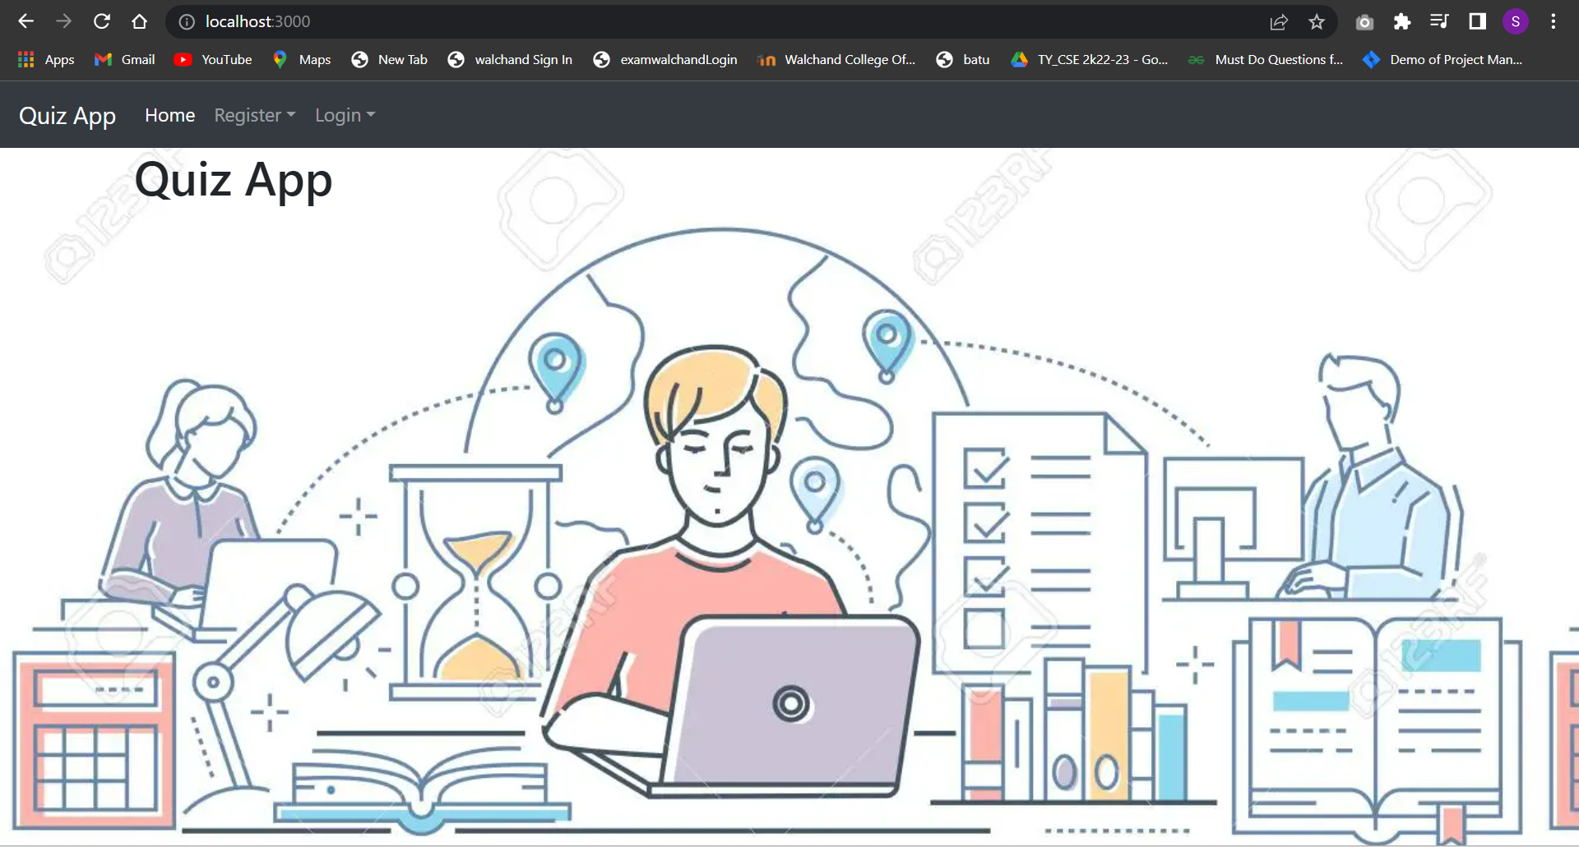

Register:

Student login:-

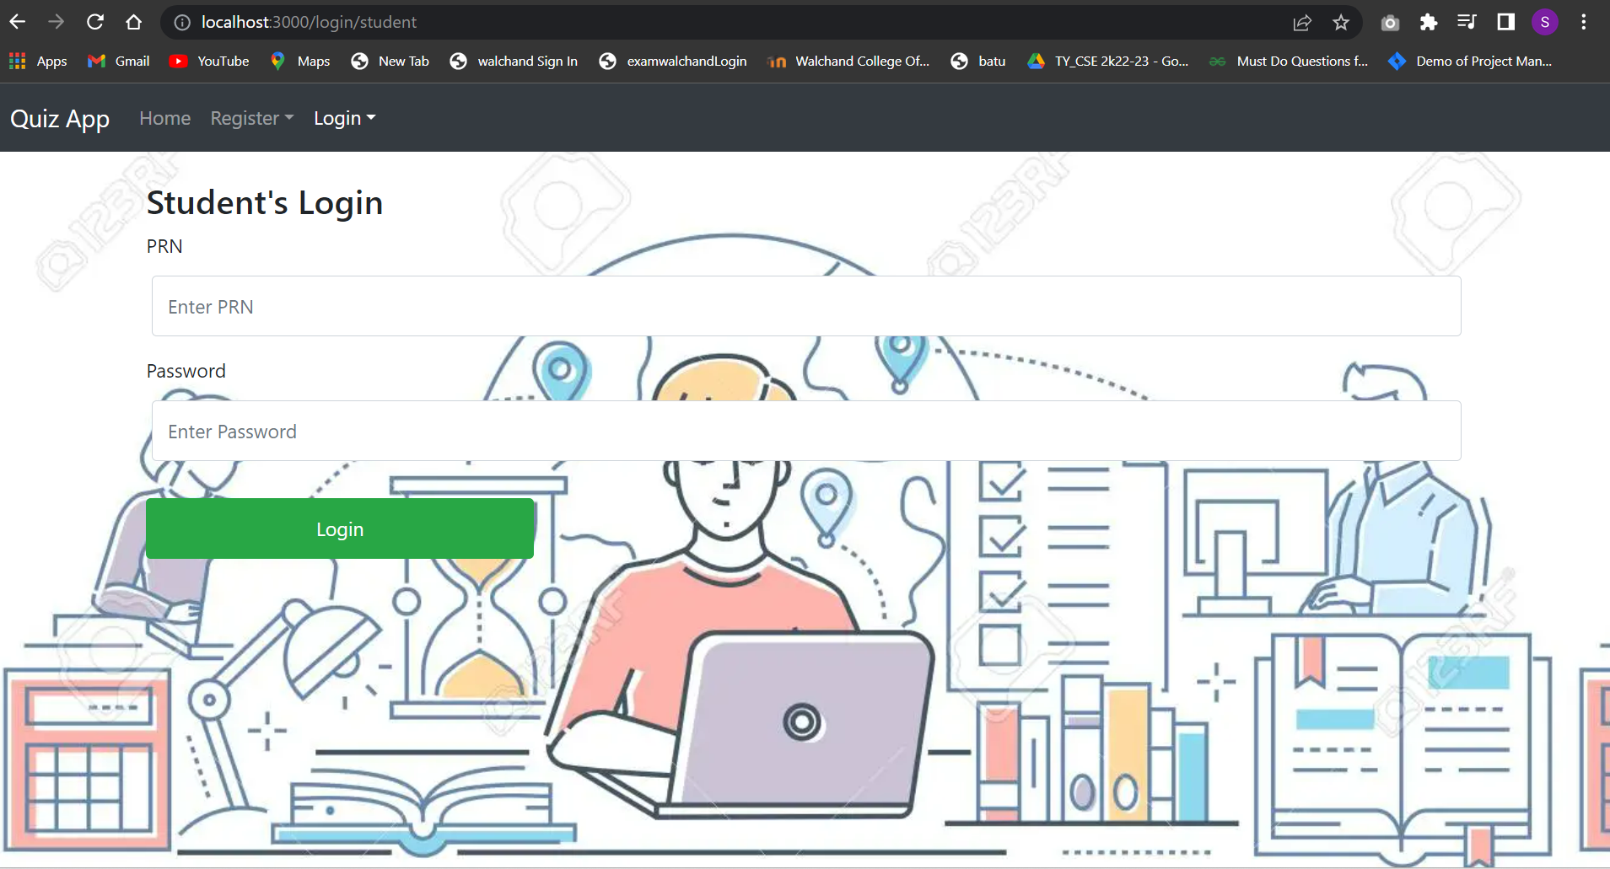

Teacher login:-

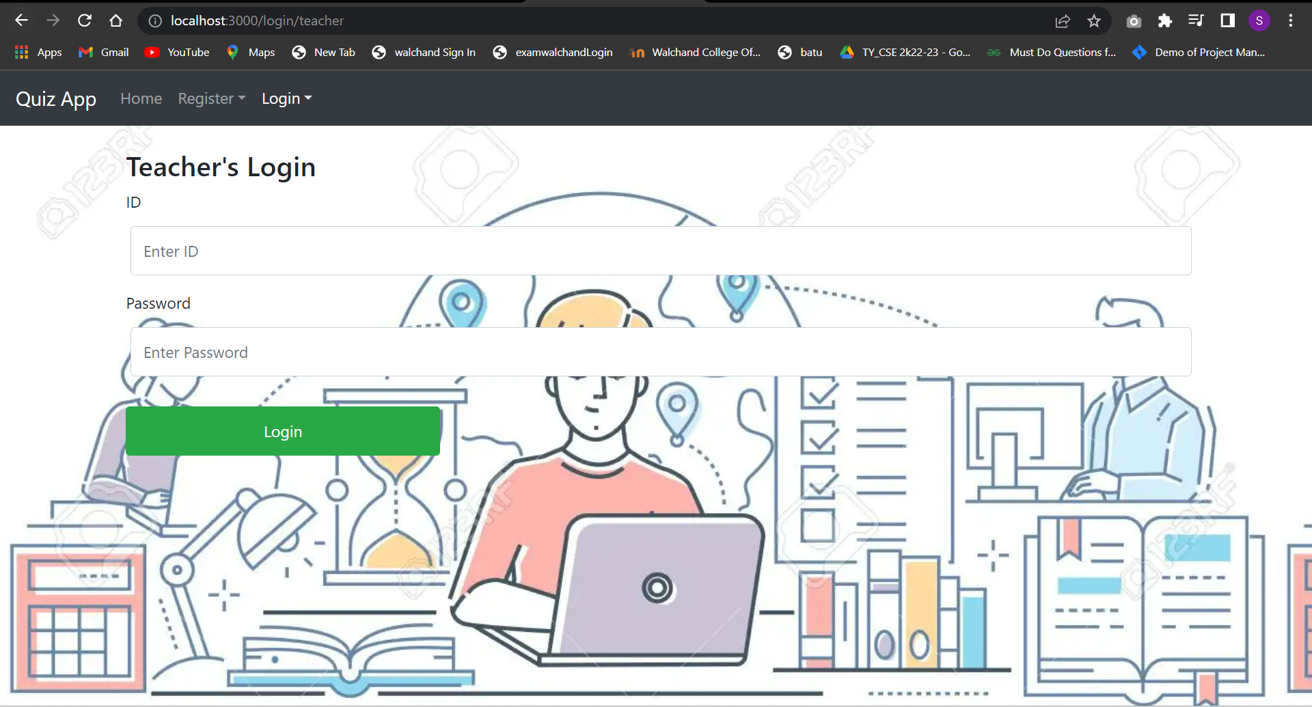

Create Quiz

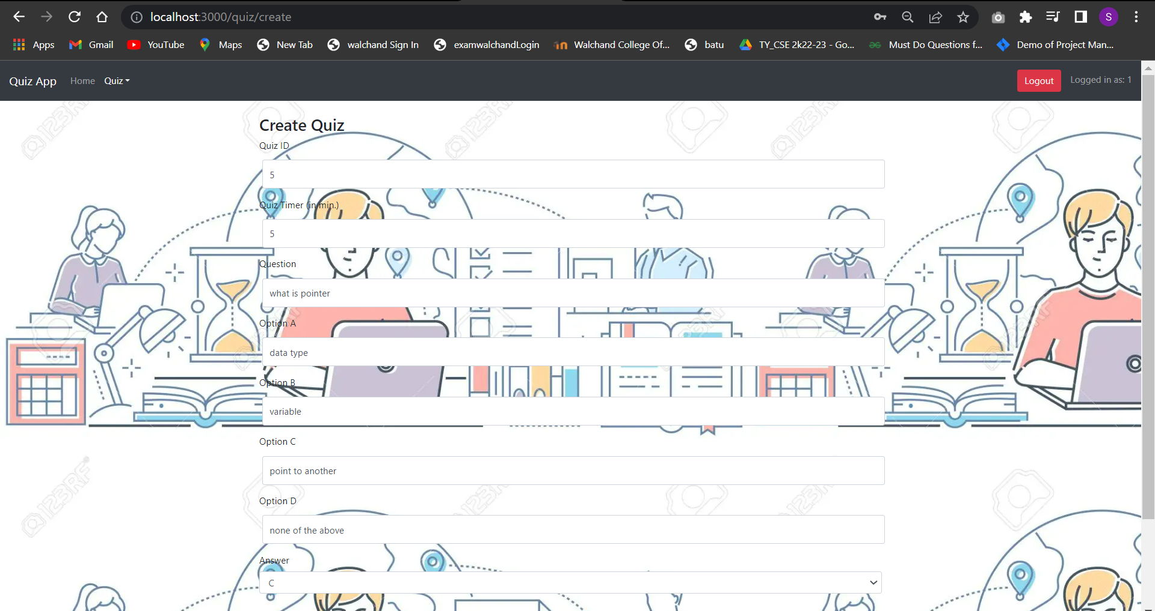

Student View:

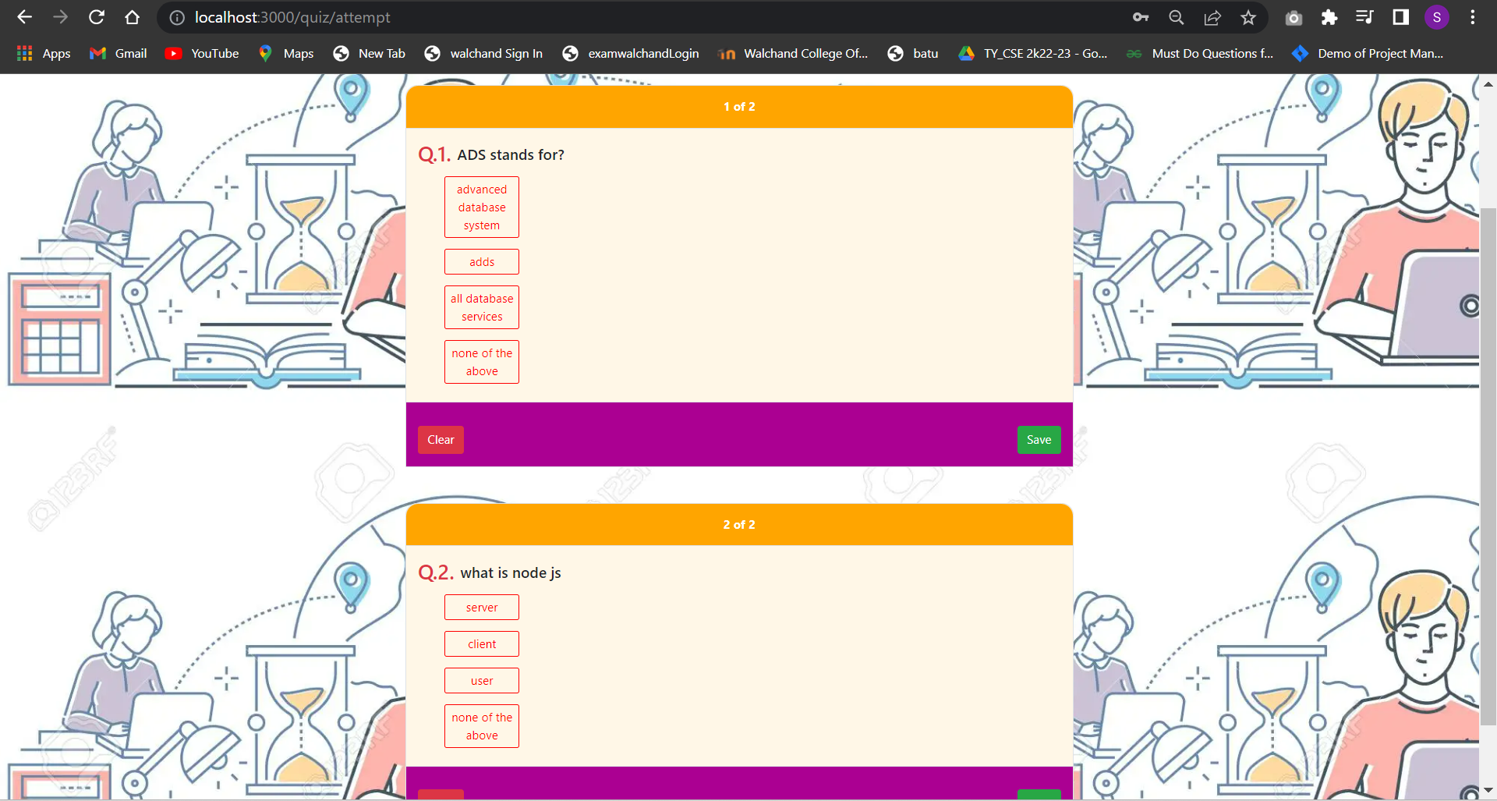

### Quizes Result

### 

Conclusion:

Designed and implemented a web-enabled (portal) quiz portal.